Results on pilot activities:
Good practice piloted | Walk of fame but we renamed it as FP ABANTEAN IS SOCIAL
VET college which carried out the pilot activity and network | 12 schools: centro formación Somorrostro, Goierri eskola, Maristak Durango, Zabalburu, MGEP, Centro formativo Otxarkoaga, San Viator, Irungo La Salle, Egibide, PI TXorierri, Salesianos Deusto, Nazaret zentroa
Period of implementation of the pilot | February 2021 but is still open
Target group (students, teachers, companies…) | Baccalaureate and Secondary Education students. We want to show them that studying in our VET Schools they could participate in interesting projects linked to the SDG 2030 goals. It´s also useful for women, to show them that it´s possible to help people from technical studies too (women STEAM)
Resources necessary to implement the good practice (staff, facilities, equipment…) | We created a working group with the heads of communication from the interested schools (4 meetings: October 26th 2020, Nov23th 2020 , December 14th 2020, February 1st 2021) and in these meetings we defined: how we were going to implement the good practice, select the initiatives from schools, design the blog, edit a pilot video to decide the final script for the videos of the initiative, redact a press release,…  We worked with a press agency to move the press release into the media (we got some radio interviews and newsletter impact)  We also designed the blog using blogger
Link to an existing EU policy (*) | - External drivers of change: megatrends, government policies, climate crisis  - Local/ regional development needs  - International cooperation
Link to a particular aspect of the VET policy (**). Please, also mention if the good practice is related to any EU initiative/tool in the field of VET (EntreComp, DigComp, Europass, ECVET) | EU Skills Week.  Transversal competences. The good practice is aimed to give visibility to activities carried out by VET colleges related to inclusion and sustainability in all its forms (environmental, social and economic).
Description of the work done during the pilot (please, explain the process you followed as completely as possible) | We discussed the possibilities of the Dutch Walk of fame initiative and how to organize in HETEL within the working group on communication. In this working group we also underlined that one of the core values that represent our VET Schools is the importance of the values, the solidarity, etc that somehow are gathered in the 17 SDG. We asked our schools to select / work out an experience linked to the SDG 2030 (sustainability, reduce inequalities, no poverty…). We asked them to encourage the students who were involved in these experiences to make a video explaining their experience and how they made them grow as persons, be aware of the differences and how lucky we are in this part of the planet. We also asked them to send us a picture and a text.  At the same time, career guidance experts have noticed that women choose their studies considering the possibility of helping people, so these experiences have also been useful to show that they can help people studying technological VET studies or programmes.  We designed the image and name of the initiative and edited all the videos/ images and text that we received from the schools. And we included a banner at the home of our website.  We designed the blog and sent a press release to several media telling them how our schools are committed with the 2030 SDGoals.  We showed some initiatives of this blog in the orientation speeches with secondary education or baccalaureate students too.  The blog is open, and we will gather new initiatives each year from different schools.  We presented the good practice to our colleagues in NoN WP4.2. and the Dutch partners were very happy with this new version of their experience and were going to show to their colleagues and try to do something similar too.
Did you adapt the good practice? Why and how? | Due to Covid restrictions we only made the online part of the Dutch Walk of fame initiative. We also changed the “protagonist” and instead of selecting VET students who have obtained a prize, we selected initiatives related to the SDG 2030
Which challenges you found to pilot the good practice? (covid restrictions, resources, adaptability to a different educational context…) | The most difficult part has been to get a video of all the initiatives, because some of them took part in 2020 and it was difficult to ask their protagonist to make all the elements we were asking for. Involving the schools in this initiative has also been quite challenging.
Which was the impact (what did you gain) with the pilot of the good practice? (development of teachers´ skills, introduction of new contents or new methodologies in your curriculum, impact in the communication strategy of your organization, new ways of engaging with companies…) | Impact in the communication strategy to engage young people to VET studies.  The 2 most important Basque newspapers echoed our initiative. Also, we had interviews in several radio broadcasts.  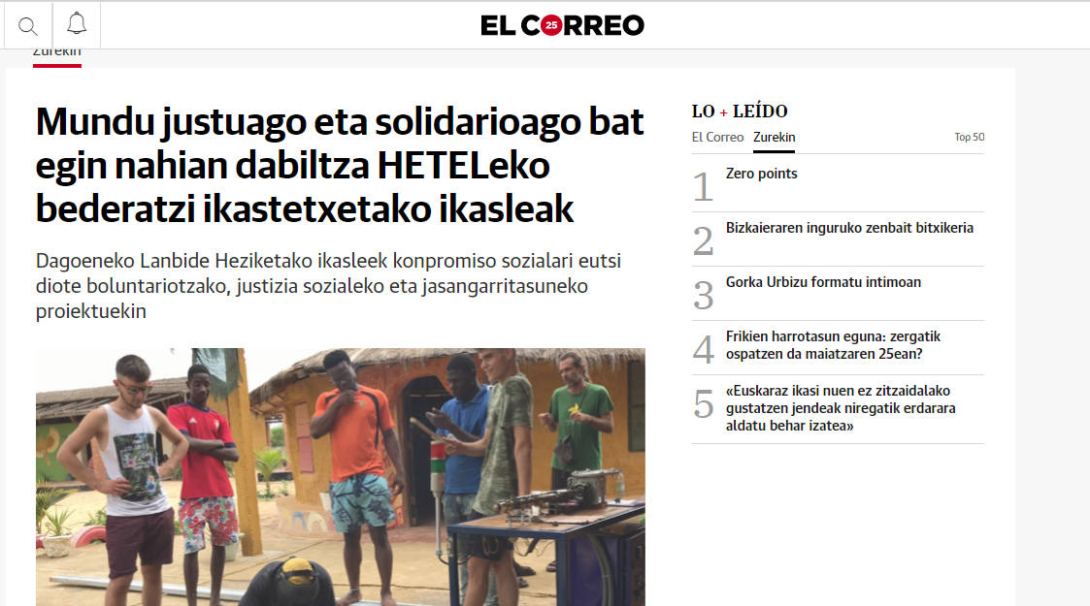
Are you implementing the good practice or some of its elements in your organization? (for example, training of staff, communication activities…). Please indicate how. | Yes, we are including this initiative in our communication actions with secondary education and baccalaureate students, also within our working group dedicated to career guidance.
Have you transferred the good practice (totally or partially) to other departments of your school, other schools or other organization? Do you think it would be interesting to do it? | We transferred the practice to all the schools in our network trying to involve them in the initiative and 2 new schools got involved (from 9 to 12). We are confident more will join us the next year.

(*) The EU policies to choose from, are these ones (we have made a preselection).
- External drivers of change: megatrends, government policies, climate crisis
- General responsiveness to external change
- Digitalisation, automation (of tasks and jobs) and AI
- Disruptive technologies
- Future jobs
- Anticipation of labour market needs
- Matching skills and jobs/ Skills mismatch/ Upskilling, Reskilling
- Co-design and co-delivery of VET with the labour market
- Local/ regional development needs
- Financing of VET/ diversifying revenue sources
- EU policies on VET
- EU funding (for VET cooperation and development)/ Erasmus 2021-2027
- European cooperation
- International cooperation (outside EU)
- Innovation
- Entrepreneurship
- Migration
- Demographic changes

(**) The aspects the EU VET policy deals with are:
- General strategy work on VET provider level
- International strategy on VET provider level
- Quality assurance and management
- Staff recruitment and retention
- Lifelong learning/ continuous learning
- Adult education
- Flexible VET pathways
- Pedagogy
- Virtual/ Online courses
- Work-based learning
- Permeability
- Transition phases/ cooperation with primary education and/or HE
- Transversal competences
- Key competences (literacy, numeracy)
- Avoiding drop-outs
- NEETs
- Special needs learners
- Role of parents/ guardians

