WORK PACKAGE 4 – CAPACITY BUILDING
TEMPLATE FOR COLLECTION OF GOOD PRACTICES

Name of the best practice | Walk of Fame Deltion College
Country | The Netherlands
Description | 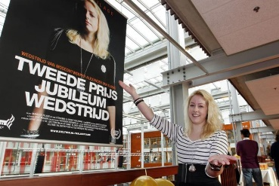    Chefs, stylists, technical experts, Skills champions, VET ambassadors? They just walk around in Deltion College.  Our students win the best prices nationally and also internationally.  View our students on the Campus Walk of Fame.  Contributes to the possitive appearance of VET  Aim: inspire other students, make notice that they are seen for their good efforts. And show visitors, potential students and companies (online and offline) that we are really proud of our students and their achievements. Promote VET in a positive way.
Who is involved? How were they motivated to participate? | Students who won a price or earned a special title, or someone who delivered an enormous significance for society.  They are shown in the Campus Walk of Fame, on the website of the Walk of Fame, in news articles and on the social media of Deltion College. Companies inform the press when one of their employees (=student) won a title or earned a price; again promotion for VET in a positive way.  ‘Hollywood movie star setting’
Benefits | - Easy and cheap to organize;  - Media students take pictures of the students  - Show best practises; be proud about what you earned;  - Promote VET in a positive way, offline (Walk of Fame) en online (Walk of Fame website and social media attention)  - On daily basis Deltion College has got 15.000 visitors like students, staff and other visitors (like business people and companies we work together with)
Challenges and how they were overcome | x
Step by step for the implementation of the good practice (transferability to other VET college) | - Show best practises of students, starting with earned prices or titles.  - Student AV make pictures of the students.  - Promote achievements also online (website and social media)
Target group | - Students, visitors Campus Deltion College, press, companies who are involved, industry

