EUROPEAN TOOLS FOR VOCATIONAL EDUCATION AND TRAINING

1.1. European tools to facilitate mobility and promote joint projects
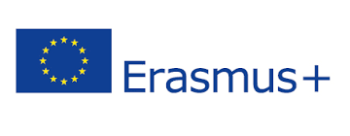

ERASMUS+ PROGRAMMES: KA1 programs. Mobility for students and teachers for the exchange of good practices, teaching, studies and internships. KA2.- Cooperation for innovation programmes for the exchange of good practices for educational centres. Programmes KA3.- Support for policy reform
https://ec.europa.eu/programmes/erasmus-plus/about_es

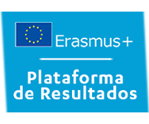
ERASMUS+ PROJECT RESULTS PLATFORM: is a tool that includes information and experiences of projects that have achieved excellent results in terms of impact and communication. This platform increases the visibility of the projects, allows the sharing of results, serves as a source of inspiration and even facilitates the meeting of future partners for other projects.
http://sepie.es/comunicacion/resultados.html

SCHOOL EDUCATION GATEWAY: aims to provide schools with the help they need to start and develop Erasmus+ projects in the School Education sector. In addition, it offers general information about Erasmus+, compilation of good practices, tutorials and news related to the programme. It also offers a catalogue with information about face-to-face training courses, online courses and different pedagogical material.
http://sepie.es/educacion-escolar/school-gateway.html

1.2. Tools for the presentation of competences and qualifications
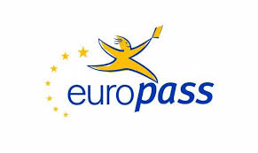

EUROPASS: this is a common documentation system, which enables European citizens to present their skills and qualifications in a simple and easily understandable way throughout Europe. Its website includes interactive tools that, for example, allow users to create a curriculum vitae in a common European format.
https://europass.cedefop.europa.eu/es

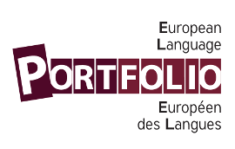
EUROPEAN LANGUAGE PORTFOLIO: The European Language Portfolio (ELP) is a personal document promoted by the Council of Europe in which those who learn or have learned a language, whether at school or outside, can record their experiences of language and cultural learning and reflect on them.
http://sepie.es/iniciativas/portfolio/index.html
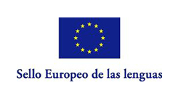
EUROPEAN LANGUAGE SEAL: The "European Label for Innovative Initiatives in Language Teaching and Learning" is an initiative of the European Commission which reflects the interest in encouraging language learning as a necessary vehicle for genuine European integration. This award distinguishes innovative experiences in the field of language teaching and learning (including sign language), whether foreign, national, regional or migrant community-based, carried out by citizens.
http://sepie.es/iniciativas/sello/index.html
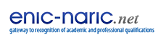
ENIC-NARIC: The National Information Centres for the Recognition of Academic and Professional Qualifications provide information and advice on the recognition of qualifications and periods of study and training abroad.
https://www.enic-naric.net/spain.aspx

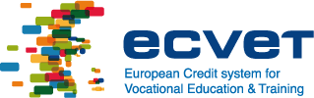
ECVET: is a system of accumulation and transfer of units of learning outcomes. The units are made up of knowledge, skills and competences. In concrete terms, a pedagogical contract is signed between the home and host institutions before the learner goes abroad. In this contract, both centres define the learning results to be obtained and the conditions for their evaluation, validation and recognition. At the end of their stay, the host school assesses the results. The centre of origin, on the other hand, validates and recognises the "learning credits" that will be added to the points already obtained by the student in order to obtain the required qualification.
http://www.todofp.es/en/profesores/europa/fp-europa/ecvet/que-es-ecvet.html
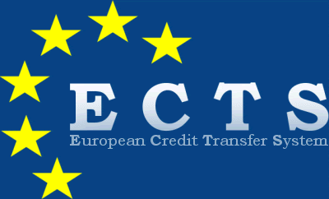
European Credit Transfer and Accumulation System (ECTS): is a tool of the European Higher Education Area (EHEA) to make qualifications and courses more transparent. It aims to make national education systems more compatible at international level. ECTS makes it possible for credits taken at a higher education institution to be valid for a degree studied at another similar institution. ECTS credits represent training based on well-defined learning outcomes and workloads.
http://www.eees.es/es/ects
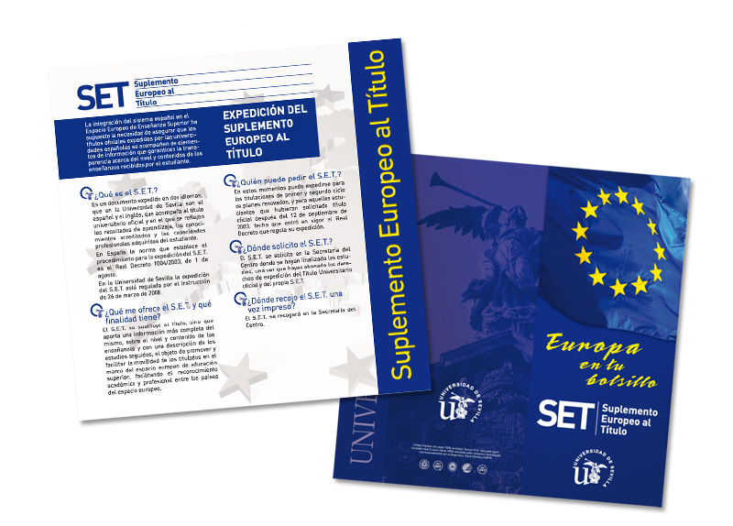
SUPPLEMENT TO THE HIGHER DEGREE: this is a document attached to an official higher education or higher vocational education qualification in which the knowledge and skills of the holder are described. It complements the information contained in official certificates and diplomas, making them easier to understand for third parties, in particular employers or institutions in a country other than the one issuing them.
https://europass.cedefop.europa.eu/es/taxonomy/term/90

1.3. Information tools on studying and working in Europe
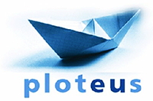
PLOTEUS: aims to help students, job seekers, workers, counsellors and teachers find information about learning opportunities in Europe.
https://ec.europa.eu/ploteus/es/home
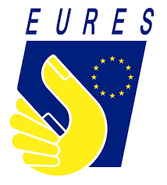
EURES: provides information on employment and learning opportunities in Europe. The purpose of EURES is to provide information, advice and recruitment/placement (job search) services to workers and employers, as well as to any citizen wishing to benefit from the principle of free movement of persons.
https://ec.europa.eu/eures/public/es/opportunities
EUROGUIDANCE: is a network of centres distributed throughout Europe that establishes points of union between the European Guidance Systems. Euroguidance promotes mobility, helping guidance counsellors or others to better understand the opportunities available to European citizens in Europe.
https://www.euroguidance.eu/
ERASMUS INTERN.ORG: In order to facilitate the search activity of companies interested in hosting students, the National Agencies of the Erasmus+ programme agreed to use this common platform for the publication of internship offers. The platform allows companies to register their internship offers and students and organisations to search for interested companies.
http://erasmusintern.org/
ERASMOBILITY: is a free platform where schools help each other to find internships (FCTs) abroad. The philosophy of this platform is based on encouraging vocational training centres to make proposals for the exchange of placements, with filtering options that make it possible to carry out searches that are appropriate to the objectives of each institution.
http://www.erasmobility.com/

1.4. Educational tools
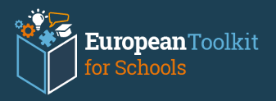
European toolkit for schools: provides concrete ideas for improving collaboration within schools, between schools and outside schools with a view to enabling all students to complete their education successfully. School leaders, teachers, parents and others involved in different aspects of school life can find useful information, examples of measures and reference materials to inspire them to provide high quality and effective school education even from early childhood. The aim of these tools is to support the exchange and transfer of good practices and experiences between education professionals and policy makers.
https://www.schooleducationgateway.eu/es/pub/resources/toolkitsforschools.htm
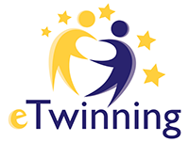
eTwinning PLATFORM: this platform brings together the largest European community of teachers and schools. The aim of eTwinning is to promote and facilitate contact, the exchange of ideas and collaborative work between teachers and pupils in European countries through ICT. In addition to providing opportunities for interaction and training, teachers and pupils from two or more schools in different European countries can develop collaborative projects through this Internet platform on any topic agreed by the founders.
https://www.etwinning.net/es/pub/index.htm

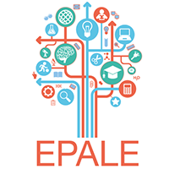
EPALE: is a multilingual community of adult learning professionals. It aims to foster collaboration to improve the quality and delivery of adult learning services in Europe, to strengthen the adult learning sector at a pan-European level and to enable adult learning practitioners and promoters to reach the whole adult population.
https://ec.europa.eu/epale/es

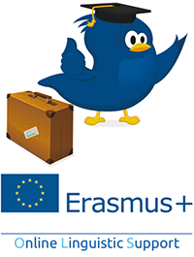
OLS (Online Linguistic Support): This website provides online linguistic support and allows Erasmus+ participants to improve their knowledge of the language in which they will work, study or volunteer abroad in order to make the most of this experience.
http://erasmusplusols.eu/

